Concise, Concrete, and Attractive Title Less Than 200 Characters

Taro Shinku, ^{a, †} Yoshio Hyomen ^{b, ‡}

ª Department of Advanced Physics, University of Hongo, 5-25-6 Hongo, Bunkyo-ku, Tokyo 113-0033, Japan
^{b} Department of Chemistry, Institute for Vacuum and Surface Science, 2-12-1 Ookayama, Meguro-ku, Tokyo 152-0033, Japan
† Present address: Department of Electrical Engineering, University of Hongo, 5-25-6 Hongo, Bunkyo-ku, Tokyo 113-0033, Japan
‡ Corresponding author: tshinku@ee.u-hongo.ac.jp

Abstract
A paper for publication must be preceded by a self-contained abstract setting out the essential contents. The length should be no more than 500 words. The Times New Roman with 10 points should be used. A graphical abstract figure is required. The figure should be closely related to the content of the manuscript and capture reader’s attention. The aspect ratio of approximately 2 : 1 is recommended. Characters, if used in the figure, must be large enough so that they are easily recognizable. The abstract figure also appears on the J-STAGE journal website.

Keywords Short and Concise; More than 3 keywords; Less than 5 keywords; Italic times new roman; 10 points

I. INTRODUCTION
Superexpress Letters are short reports that should be urgently published with less than 3 journal pages including figures. The letters would appear on the website in 4 working days after submission if accepted as it is. In the cover letter, the authors should describe the novelty and significance of the work that deserve the priority handling of Superexpress Letters.
Title of the manuscript should be concise, concrete, and attractive for broad range of readers. The length is limited to less than 200 words. The font and the size are Arial and 22 points, respectively.
Authors’ names are given by Times New Roman with 12 points. Each author should be specified by at least one affiliation, and at least one author should be indicated as a corresponding author with his/her e-mail address.
The authors’ affiliations, present addresses (if any), and corresponding authors’ e-mail addresses are given by Italic Times New Roman with 9 points. The affiliations should be distinguished by a, b, c, etc. The present addresses and the corresponding author’s e-mail address should be tagged by, in order, †, ‡, §, ||, and ⊥.
Times New Roman with 10 points must be used to write the body of the context. Letters with diacritical marks (e.g., á, ä, ł) are also used. Use of other fonts is not allowed except for Greek letters, mathematical symbols, etc.
References must be cited as [1, 2] or [1-4, 5] in the text. Please see Section IV for more details about the references.

II. SECTION TITLE
A. Subsection title
1. Sub-subsection title
Because of the limited length of the Superexpress Letter, there is no need to sectionalize the manuscript. However, you can of course make Sections, Subsections, and Sub-subsections. The font of the section titles is Arial. The font sizes are 14, 12, and 10 points for Sections, Subsections and Subsubsections, respectively. Section should be numbered as I, II, III, etc. All letters of the section title must be uppercase. Subsections should be distinguished by A, B, C, etc., and Sub-subsections should be numbered as 1, 2, 3, etc. Only the first letter of the titles is expressed by an uppercase letter for Subsection and Sub-subsection.
Acknowledgements, Appendices, and References are not numbered. For Appendices, however, A, B, C, etc., should be put after “Appendix” if there are more than two Appendices. Please see Appendices below for more details.
When you refer to a certain section, you may express as “Section II.A”, “Section III.B.2”, “Appendix A”, etc.

III. FIGURES AND TABLES
Figures and tables must be numbered by Arabic numerals (e.g., Figure 1, Table 2). If a figure is composed of multiple panels [e.g., (a), (b), (c), and (d)], and you want to refer to a part of them, you can express as “Figure 1(a)”, “Figure 1(a, c)”, or “Figure 1(a-c)”. When multiple figures or tables are mentioned, “Figures 1 and 2”, “Figures 1(a) and 2(b)”, or “Tables 1 and 2” is used. An abbreviation form of Figure (i.e., Fig.) should not be used.
Tables should be kept to the minimum. The same data should not be reproduced in both tabular and diagrammatic forms. Essential tables should be provided with legends making them intelligible without reference to the text.

A. Figure format
Figures, including a graphical abstract figure, and illustrations are acceptable only in TIFF, JPG, PDF, or EPS formats. MS Office files (Word and Power Point) are also accepted. After acceptance, you are asked to upload figure files with a higher resolution besides the manuscript file.

B. How to embed figures and tables in the manuscript
Figures and tables can be displayed anywhere in the manuscript. However, please make sure that you can display only one figure or table in a page. Figure or table captions should be placed on the same page where the figure or the table is displayed. The resolution
Embedding figures with a moderate resolution is accepted for keeping the manuscript file size small. However, what is shown in the figure must be clearly displayed so that an editor and reviewers can easily grasp it. If the resolution is low, we may request the authors to resubmit the manuscript before the manuscript is passed to the editor.
In the published manuscript, the maximum size of the width is 86 mm in a single-column figure. For a two-column figure, the maximum width is 181 mm. Thus, the use of too small characters must be avoided. We strongly recommend the authors to check the visibility of the figures in the actual size. Although it is not always accepted, you can request the size of the figure/table in the published manuscript. Please indicate your request on the figure and table pages.

C. Preparation of tables
Tables can be created by using a Word table function. Alternatively, you can create tables by other application software and put them in the pages as figures.
In the printed manuscript, the size of the font used in the table is 10 pt. Large tables which cannot be displayed in a single page should be divided into several tables.

IV. REFERENCES
Reference numbers in the main text must be put in square brackets like [1], [1, 2], and [1-4, 5]. When a reference is cited in a sentence, an expression should be something like; “.... See Ref. 1 for more details.” An abbreviation form (Ref.) is used.
The number of references cited in a Superexpress Letter should be 10 at the minimum. If the number of cited references is less than 10, the editorial office may ask the authors to adjust the number.
In a reference section, bibliographic data is given by 9-point Times New Roman characters. Following expression rules must be adopted. Do not forget DOI. Some book chapters have their own DOIs. DOIs are used to make a hyberlink to the source so that they do not apparently appear in a published PDF file.

(1) Journals:
[1] Author 1, Author 2, and Author 3, Journal Title in Abbreviation, Vol. in bold, First page (Year).
https://doi.org/10.103/nmat1849
[2] Author 1, Journal Title in Abbreviation, Vol. in bold, First page (Year) (in Japanese).
https://doi.org/10.1030/ejssnt.2019.2

(2) Books:
[3] Author 1 and Author 2, Book Title in Italic (Publisher, Location, Year) Chapter number (or Page).
[4] Author 1, Author 2, Author 3, and Author 4, in; Book Title in Italic, edited by Editor 1 and Editor 2 (Publisher, Location, Year) Chapter number (or Page).
https://doi.org/10.1007/978-3-642-56019-4

(3) Dissertation:
[5] Author, Title of Dissertation in Italic, Ph. D. thesis, University Name, Year.

(4) Conference presentation:
[6] Author 1, Author 2, and Author 3, Conference Name (Place, Year) Presentation number.

The journal abbreviation can be checked in the following National Center for Biotechnology Information (NCBI) web site.
https://www.ncbi.nlm.nih.gov/nlmcatalog/journals

V. SUPPLEMENTARY MATERIAL
Supplementary Material can be published along with the main article. It should provide additional substantive material but must not include discussion or key analyses. Authors are required to provide a short description of the content. Please see Appendix B for an example.
A PDF file is preferred, but a Microsoft Word file is accepted. Movies and animations with any formats can also be provided. However, an animation GIF file is recommended because not every reader has Media Player or Quick Time.
When you refer to a figure given in Supplementary Material, the expression should be, for example, “... is shown in Figure S1 in Supplementary Material.”

VI. CONCLUSIONS
A conclusion or summary section is also optional for a Superexpress Letter.

Acknowledgments
Only scientific, technical, and financial support should be acknowledged. The font size of 9 pt are used here.

Appendix A
Appendices for subsidiary subjects such as derivations of some equations, calibration of some experimental parameters, and so on, can be offered in the following two ways:
(1) The appendices are presented between the acknowledgement section and the reference section.
(2) The appendices can also be provided in a separate file as Supplementary Material.
Appendices are distinguished by A, B, C, etc. However, if there is only one appendix section, no need to put “A”. The size of the font used in Appendix is 9 points.

Appendix B
Determination of spatial overlap between the laser and the synchrotron radiation and Calculation of the surface oxygen defect density are available in Supplementary Materials at https://doi.org/10.1380/ejssnt/2019.12.

Appendix C
e-Journal of Surface Science and Nanotechnology (eJSSNT) will respond harshly to any violation of the contemporary codes of publication ethics. We will decide how to treat such violation referring to, e.g., guidelines and flowcharts proposed by Committee on Publication Ethics (https://publicationethics.org/resources).

References
[1] A. K. Geim and K. S. Novoselov, Nat. Mater. 6, 183 (2007).
https://doi.org/10.103/nmat1849
[2] C. Liu, I. Matsuda, R. Hobara, and S. Hasegawa, Hyomen Kagaku 12, 702 (2006) (in Japanese).
https://doi.org/10.1380/jsssj.27.702
[3] R. Su, R. Bechstein, L. Sø, R. T. Vang, M. Sillassen, B. Esbjornsson, A. Palmqvist, and F. Besenbacher, J. Phys. Chem. C 115, 24287 (2011).
https://doi.org/10.1021/jp2086768
[4] S. Hüfner, Photoelectron Spectroscopy (Springer-Verlag, Berlin, Heidelberg, 2003) Chap. 4.
https://doi.org/10.1007/978-3-662-09280-4
[5] H. Yamada, in; Noncontact Atomic Force Microscopy, edited by S. Morita, R. Wiesendanger, and E. Meyer (Springer-Verlag, Berlin, Heidelberg, 2002) p. 193.
https://doi.org/10.1007/978-3-642-56019-4
[6] J. Fujii, in: Compendium of Surface and Interface Analysis, edited by The Surface Science Society of Japan (Springer Nature, Singapore, 2018) p. 707.
https://doi.org/10.1007/978-981-10-6156-1_114
[7] M. Luo, An STM Study of Molecular Self-Assemblies on Cu (111): Structure, Interaction, and Effects of Confinement, Ph. D. thesis, University of California-Riverside, 2012.
[8] J. R. Morales-Cifuentes and T. L. Einstein, APS March Meeting (Baltimore, 2013) M6.00007.

All articles published on e-J. Surf. Sci. Nanotechnol. are licensed under the Creative Commons Attribution 4.0 International (CC BY 4.0). You are free to copy and redistribute articles in any medium or format and also free to remix, transform, and build upon articles for any purpose (including a commercial use) as long as you give appropriate credit to the original source and provide a link to the Creative Commons (CC) license. If you modify the material, you must indicate changes in a proper way.
Published by The Japan Society of Vacuum and Surface Science

Table 1: Pore dimension of various types of zeolite.

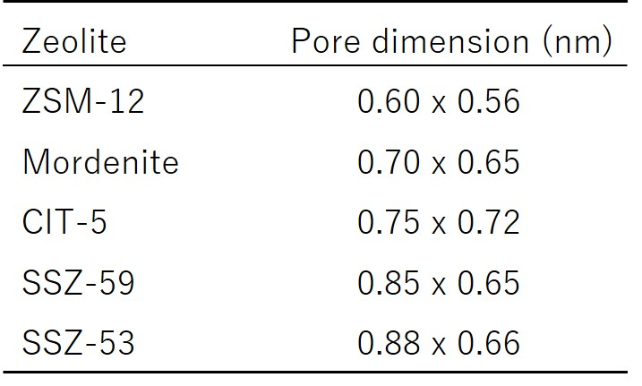

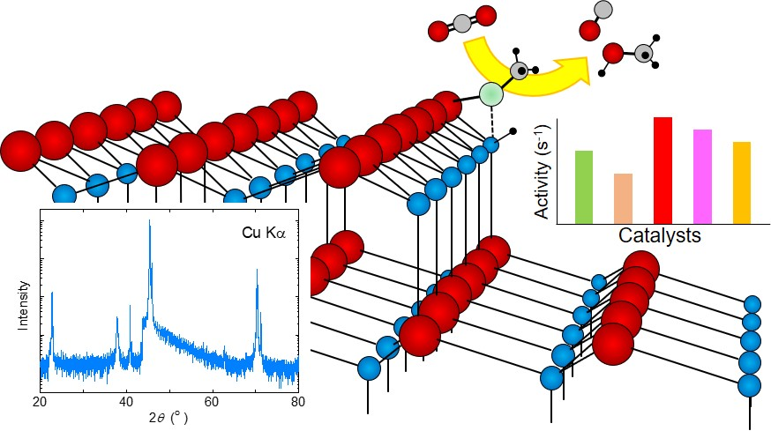

Graphical abstract
(No caption is required for the graphical abstract. An aspect ratio of 2:1 is preferred.)

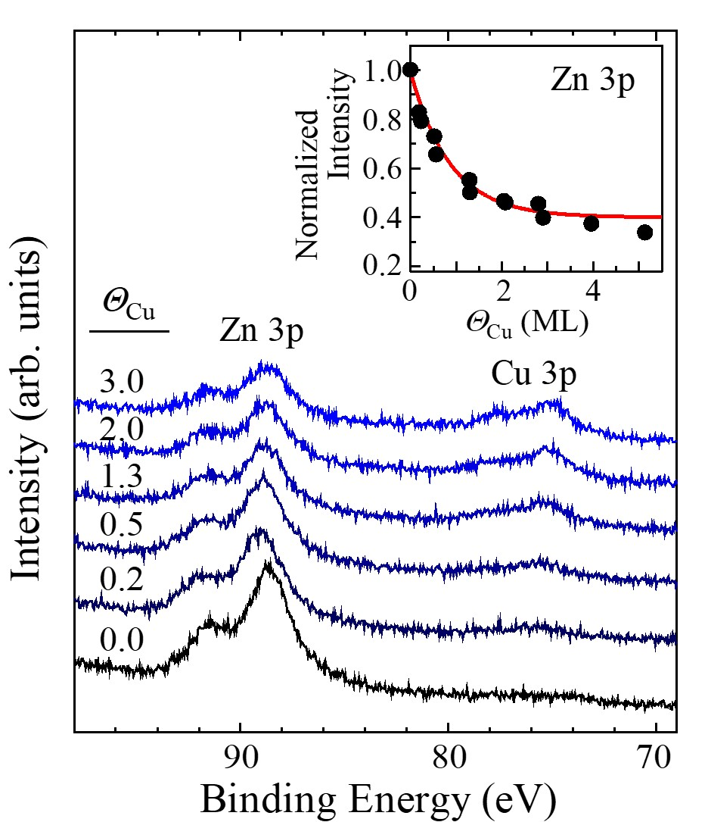

Figure 1: Normal-emission spectra of the Cu-covered ZnO(0001)-Zn surfaces at various Cu coverages. The incident photon energy was 170 eV. In the inset, the integrated intensity of the Zn 3p peak is plotted by dots against the Cu coverage.

Requested size: single-column figure
(optional)

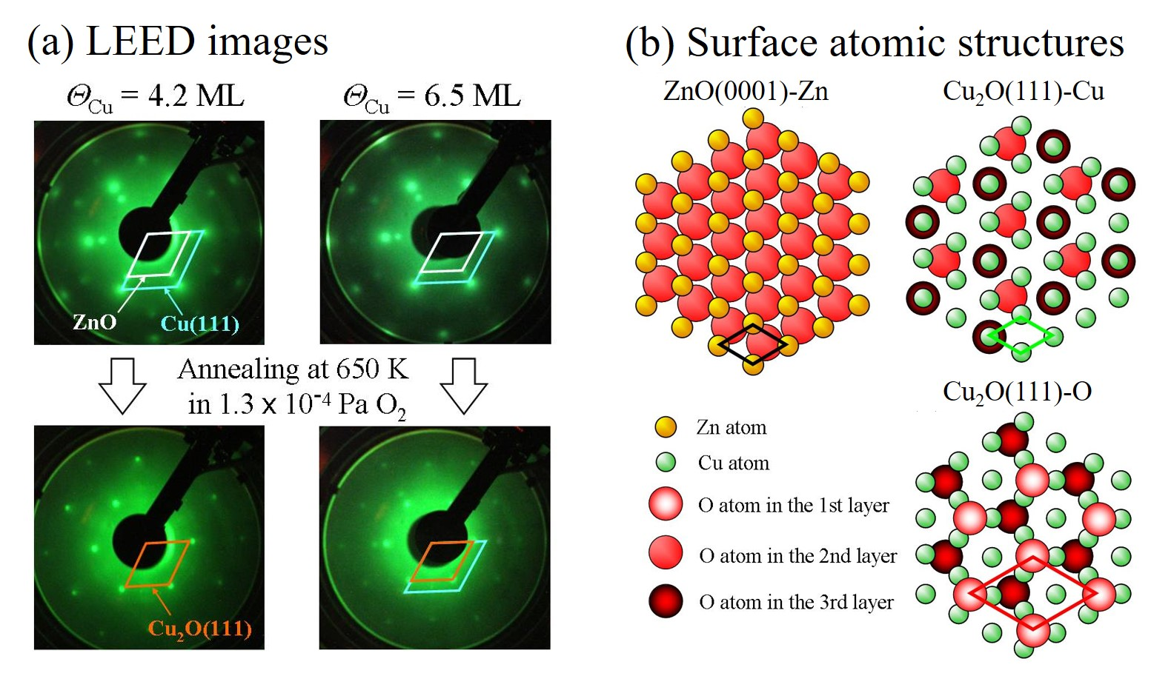

Figure 2: (a) LEED images of the Cu-covered ZnO(0001)-Zn surfaces (Cu coverages of 4.2 and 6.5 ML) and their oxidized surfaces. The primary energy of the incident electron beam was 143 eV. (b) Schematic models of the bulk-terminated surfaces; ZnO(0001)-Zn, Cu₂O(111)-Cu, and Cu₂O(111)-O.

Requested size: two-column figure
(optional)

