Template of Abstract for The 10th International Symposium   
on Surface Science  
(Times New Roman, 16pt, bold)

Surface Kita-kyushu (Underline the presenting author.)1*, Vacuum Kokura2

1 The Japan Society of Vacuum and Surface Science, 5-25-16 Hongo, Bunkyo-ku, Tokyo, 113-0033 Japan

2 National Institute for Materials Science, 1-1, Namiki, Tsukuba, Ibaraki 305-0044 Japan

*e-mail: isss10@jvss.jp

An A4-size (210 mm × 297 mm) one-page abstract is required for each presentation, regardless of the type of presentation; invited, oral or poster. It should contain the title of paper, name of author(s), affiliation(s), postal address(es), e-mail address of the corresponding author, and main text. The abstract should be submitted in a PDF format (not larger than 10 MB) with all the used fonts embedded [1]. You can submit your abstract only through the symposium website [2].

Use **12-point Times New Roman** font for the text including author(s)' name, affiliation, references and figures/tables captions. For the title, please use **16-point Times New Roman font in bold**.

All the accepted abstracts will be available to the participants through the symposium website.

The deadline for the abstract submission is May 19, 2024.

We encourage all of you to participate the symposium, and we are very much looking forward to welcoming you at Kita-kyushu soon.

Fig. 1: You can use color figures or photographs as far as the size of the PDF file does not exceed 10 MB.

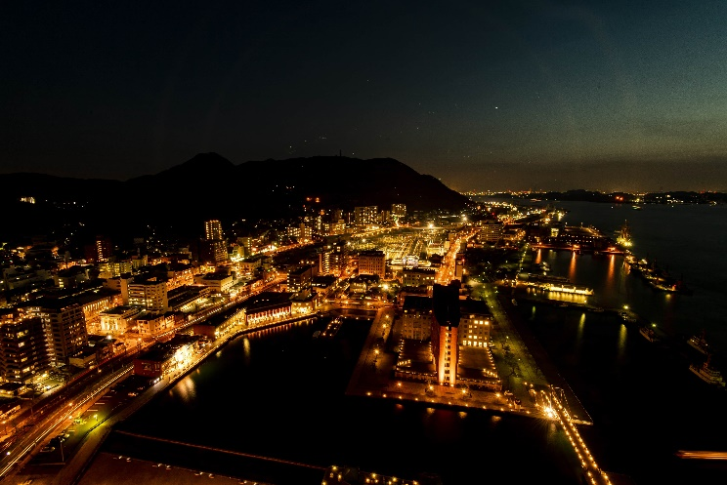

[1] S. Kita-kyushu and V. Kokura, e-*J. Surf. Sci. Nanotech.* **00**, 0000 (2023).

[2] S. Kita-kyushu and V. Kokura, *Vac. Surf. Sci.* **00**, 0000 (2023).